“This Is What We Said”
Australian Aboriginal people give their views on the Northern Territory Intervention
“This Is What We Said” will be launched in February 2010. Using pictures and quotations taken from footage of actual consultations at Bagot, Ampilatwatja, Utopia and Yirrkala, this book provides a graphic account of the depth of frustration and despair of many Aboriginal people in the Northern Territory regarding the Intervention. It is therefore tragic that legislation, about to be debated in Parliament, pays scant attention to the views expressed by many Aboriginal people during the consultations process of 2009. Also included in “This Is What We Said” are quotes on the Intervention from other well known Australians and UN representatives.
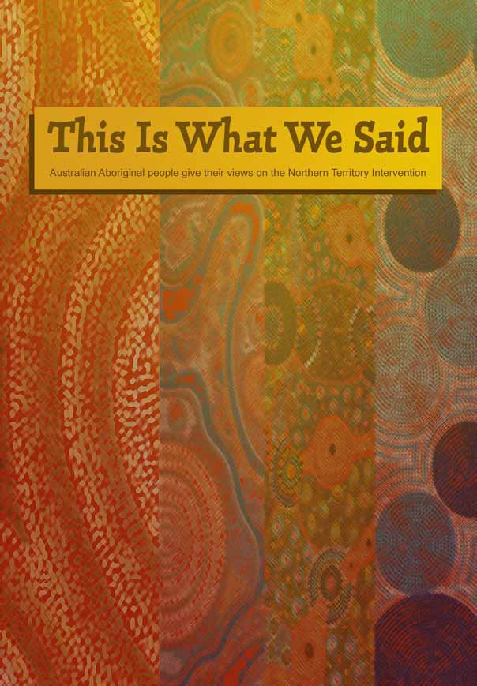
The hard back book is available at A$15 + A$2 packaging and post, per copy, within Australia. Packaging & postage is free for orders of 4 or more copies. Please note for orders larger than 4 it is best to order in groups of 9. e.g. 9, 18, 27 etc
To purchase, print and fill in the order form below, attach your cheque (made payable to Michele. A. Harris) for the total amount payable and mail to:
Michele Harris, concerned Australians, PO Box 281, East Melbourne, Victoria 8 Victoria 8002

For more information or for purchase outside Australia please contact harrisme@bigpond.com

Purchase Order Form for “This Is What We Said”

Your details (please print)
Name
Organisation (if applicable)
Address Street Suburb
Postcode State
Phone number Email
Price per copy A$15 + A$2 packaging and postage (Packaging & postage is free for orders of 4 or more copies)
Number of copies
Total payment A$ Attach cheque made payable to Michele. A. Harris

